Taller de Sistemas Empresariales

Testing funcional de servicios REST

**Grupo 16**

Federico Bentancor

Facundo Laborde

Gonzalo Santa María

Federico Sierra

Michael Rodríguez

Indice

Objetivo 3

Implementacion 4

Testing 5

Objetivo

Testear el funcionamiento de los servicios REST que expone el servidor del sistema integral de gestión de vacunas VACUNAS UY.

El testing se hace en base a los resultados esperados para tiempos de respuesta, assertions y códigos de repuesta http.

## Implementacion

Se utiliza la herramienta ReadyAPI de SOAP UI.

Se configura cada servicio con sus respuestas esperadas

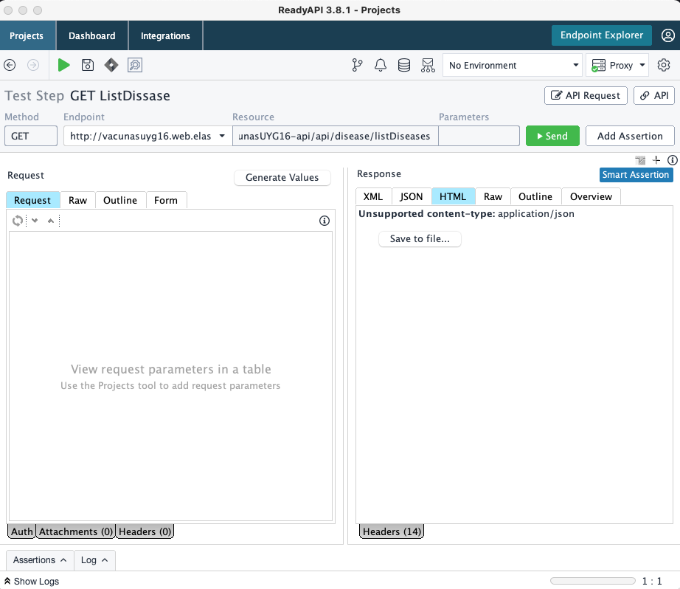

Luego se configura las respuestas (Assertions) esperadas para el servicio. La cantidad de Assertions varian según el servicio testeado, al menos 2 assetiosn por servicio se pueden encontrar.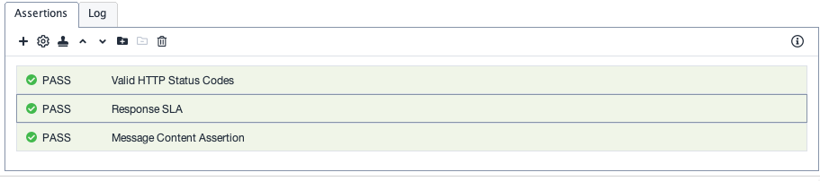

## Testing

Se testearon los servicios REST que son utilizados por los diferentes componentes del sistema.

En total son 38 servicios que se detallan a continuación.

|  |  |  |  |  |
| --- | --- | --- | --- | --- |
| Proyecto | TestCases | Errors | Failures | Time (s) |
| VACUNAS.UY.VACUNAS UY | 38 | 0 | 0 | 4.042 |

Se logro cubrir un 100% en los Assertions esperados para las respuestas de cada servicio expuesto.

Para cada servicio se configura un request code esperado, un assertion y un response SLA.

Para cada servicio varía el Assertion, los request code varían según el servicio, puede ser 200, 202 o 204 y para el response SLA se utiliza en promedio de 700 millisegundos.

El resultado para servicio testeado fue el siguiente:

|  |  |  |
| --- | --- | --- |
| Servicio | Status | Time (s) |
| /citizen/getCitizen/{id}-Request 1 Test Case | Success | 0.036 |
| /citizen/lCitizen-Request 1 Test Case | Success | 0.017 |
| /citizen/setToken/{ci}/{token}-Request 1 Test Case | Success | 0.020 |
| /disease/listDiseases-Request 1 Test Case | Success | 0.020 |
| /disease/listDiseaseById/{id}-Request 1 Test Case | Success | 0.015 |
| /laboratory/listLaboratories-Request 1 Test Case | Success | 0.031 |
| /package/lPackage-Request 1 Test Case | Success | 0.102 |
| /person/getPerson/{id}-Request 1 Test Case | Success | 0.015 |
| /person/deletePerson/{id}-Request 1 Test Case | Success | 0.015 |
| /person/lPersons-Request 1 Test Case | Success | 0.020 |
| /person/getPersonByCi/{ci}-Request 1 Test Case | Success | 0.013 |
| /Reservation/deleteReservation/{id}-Request 1 Test Case | Success | 0.000 |
| /Reservation/getReservationsSend/{idShcedule}-Request 1 Test Case | Success | 0.014 |
| /Reservation/createReservation2-Request 1 Test Case | Success | 0.019 |
| /Reservation/lReservation-Request 1 Test Case | Success | 0.592 |
| /Reservation/getReservation/{id}-Request 1 Test Case | Success | 0.046 |
| /Reservation/getunavailableDate/{idShcedule}-Request 1 Test Case | Success | 0.097 |
| /Reservation/getunavailableTime/{reservationDate}/{idShcedule}-Request 1 Test Case | Success | 0.095 |
| /Reservation/cancelReservation/{idReservation}-Request 1 Test Case | Success | 0.025 |
| /restriction/lRestriction-Request 1 Test Case | Success | 0.082 |
| /schedule/listScheduleById/{id}-Request 1 Test Case | Success | 0.092 |
| /schedule/getNextScchedules-Request 1 Test Case | Success | 0.018 |
| /schedule/listSchedules-Request 1 Test Case | Success | 0.346 |
| /schedule/deleteSchedule/{id}-Request 1 Test Case | Success | 0.020 |
| /schedule/schedulesbyVCandVP/{idVP}/{idVC}-Request 1 Test Case | Success | 0.016 |
| /VaccinationAct/listVaccinationAct-Request 1 Test Case | Success | 0.215 |
| /VaccinationAct/vaccinationActByCi/{ci}-Request 1 Test Case | Success | 0.018 |
| /vaccionationCenter/listVaccinationCenterById/{id}-Request 1 Test Case | Success | 0.025 |
| /vaccionationCenter/listVaccinationsCenters-Request 1 Test Case | Success | 0.041 |
| /vaccionationPlan/listVaccinationPlanById/{id}-Request 1 Test Case | Success | 0.031 |
| /vaccionationPlan/vaccinationCentersByVaccinationPlan/{id}-Request 1 Test Case | Success | 0.015 |
| /vaccionationPlan/listVaccinationsPlans-Request 1 Test Case | Success | 0.057 |
| /VaccinationPost/getVaccinationPostByVaccinationCenter/{id}-Request 1 Test Case | Success | 0.012 |
| /VaccinationPost/lVaccinationPosts-Request 1 Test Case | Success | 0.017 |
| /vaccinator/lVaccinator-Request 1 Test Case | Success | 0.015 |
| /vaccinator/getVaccinatorIdByCi/{ci}-Request 1 Test Case | Success | 0.013 |
| /vaccie/listVaccines-Request 1 Test Case | Success | 0.017 |
| /vaccie/getVaccine/{id}-Request 1 Test Case | Success | 0.022 |

|  |  |  |  |  |  |
| --- | --- | --- | --- | --- | --- |
|  | | | | | |
|  | | | | | | | |
|  | **Resultados** | | | | | |
|  | | | | | | |
|  |  |  | |  |  | |
|  |  | Incio |  | Mon Jun 28 14:25:51 UYT 2021 |
|  | | | | | | |
|  |  |  | |  |  | |
|  |  | Fin |  | Mon Jun 28 14:25:53 UYT 2021 |
|  | | | | | | |
|  |  |  | |  |  | |
|  |  | Tiempo total |  | 1808 ms |
|  | | | | | | |
|  |  |  | |  |  | |
|  |  | Total de casos testeados |  | 38 |
|  | | | | | | |
|  |  |  | |  |  | |
|  |  | Casos que fallan |  | 0 |
|  | | | | | | |
|  |  |  | |  |  | |
|  |  | Test Steps |  | 37 |
|  | | | | | | |
|  |  |  | |  |  | |
|  |  | Test Steps fallidos |  | 0 |
|  | | | | | | |
|  |  |  | |  |  | |
|  |  | Total de Assertions correctas |  | 83 |
|  | | | | | | |
|  |  |  | |  |  | |
|  |  | Total de Assertions fallidas |  | 0 |
|  | | | | | | |